To add skills

1. Click Skills  
   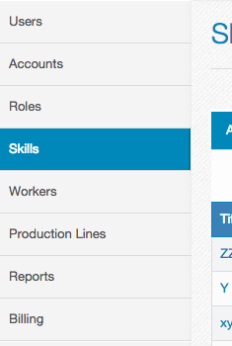
2. Click Add Skills on the right  
   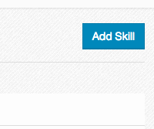
3. Give name of the skills and click Add  
   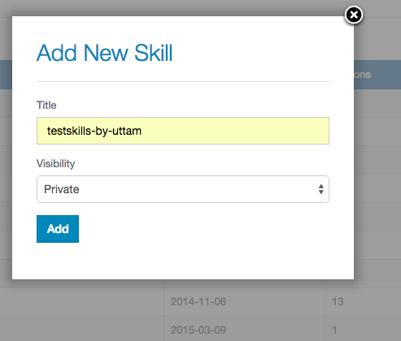

To add Skills to the production line

1. Click on the production line on the left  
   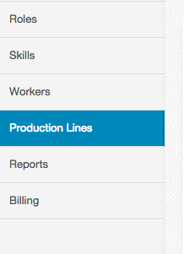
2. Click in progress if its not active and then click on your production line name.  
   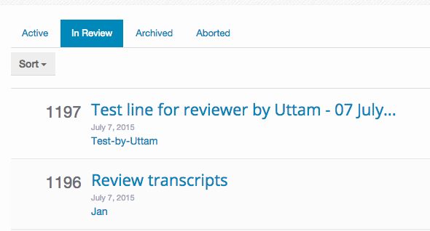
3. Click on the setting icon on the right  
   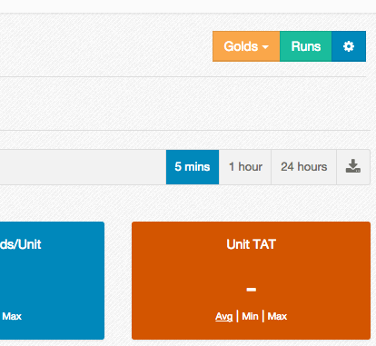
4. Click on the station name below Stations Settings  
   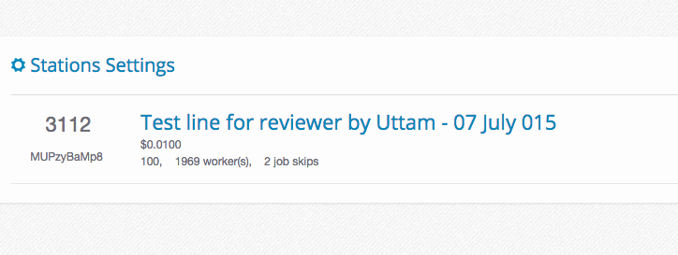
5. Then choose the Skill you want to add and click Update.  
   